Local Government

Welfare Association Jared
  - Village & PO Jared Tehsil Balakot
  - District Mansehra
Cell: +92+344+9445476
Website: www.waj.org.pk
Mail: info@waj.org.pk

WAJ Contribution in Formulation, Revival and strengthening of LG system

Brief Profile of WAJ
Welfare Association Jared (WAJ) emerged in 1988 as a non-profit and non-governmental Organization (NGO) to work for the basic rights of men, women, deprived and marginalized communities. WAJ actively advocates their human and livelihood rights to bring about the much needed policy and institutional changes in the state institutions.
In 1992, Welfare Association Jared (WAJ) implemented a program for disaster relief assistance to the victims of the flash floods in Kaghan valley of Mansehra District. This provided an opportunity to WAJ to reach the most marginalized citizens. This was a key milestone and catalyst in WAJ history as it provided the organization the opportunity to directly realize the potential of community organization. The success of this program was a key factor in galvanizing support for WAJ brand of community-based policy advocacy for empowering the marginalized.
WAJ realized its full potential in including humanitarian and rights based development work in its scope in order to complement its rights based -advocacy focus. A strategic plan was developed with Sungi increasing its outreach to the marginalized villages of District Mansehra. Since its inception, WAJ advocacy work and influence have reached far beyond its district. WAJ joined various advocacy and human rights network across the country.
Disrupting the status quo to enable the marginalized did not go without its serious challenges in Pakistan. WAJ with the close collaboration of Sungi and other likeminded civil society organization started work on the rights of forest dwellers created waves with the entrenched forest mafia who openly intimidated and threatened WAJ and Sungi’s leadership to stop organizing villagers in forested area. However Sarhad Awami Forestry Itihad (SAFI), an alliance of forest dwellers was formed and WAJ become member along with Sungi joined the policy makers in formulating the Sarhad Forest Conservation Strategy.
WAJ,s ,increased contact with communities brought out the demand for sustained development support. At the same time, the organization realized that a number of human factors were responsible for aggravating the devastation of flooding, particularly poor Natural Resource Management (NRM). WAJ established networks of village organization (VOs) of both men and also women, first time in the history of area. A supreme council of elders and ex-Local Government councilors was formed to guide WAJ in political matters.
When leader of Sungi Omar Asghar Khan (late) was instrumental in bringing together rights-based civil society organizations on a common platform called the Advocacy Development Network (ADN), WAJ welcomed the idea and joined the platform as a member organization. WAJ also joined extensive series of People’s Assemblies undertaken by Sungi to provide space for the public to reflect on and debate issues which concerned them directly but which they had not been able to voice given the absence of a democratic culture, giving them no role in the decisions enforced upon.
WAJ with the support of Sungi and other donors adopted a social mobilization approach for program implementation: Sustainable Livelihoods (Micro Finance and Enterprise Development, Natural Resource Management and Craft Skills Development), Social Sector (Health and Community Infrastructure), Policy Advocacy and Human Resource Development programs were implemented as a major partner of Sungi.

Vision
“Democratic, Peaceful, prosperous and environmental friendly society”

Mission
"Bring about democratic stability, economic prosperity by mobilizing the marginalized community in a way so that they may be able to transform their lives through NR conservation, management and development of renewable natural resources and better use of human resources.”

Goals
- Promoting democracy and peace
- Social harmony
- Poverty alleviation
- Youth engagement
- Environmental protection and promotion
WAJ was registered under Social welfare Act 1961 as non-government organization. WAJ is a rights based development entity playing an important role in development of deprived and disadvantaged segments of society, particularly in its rural areas of district Mansehra. WAJ believes in sustainable development through providing support, training NR promotion and access to economic and social development opportunities.

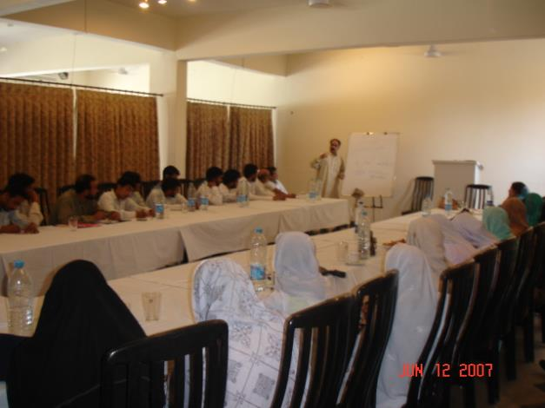
Core Programs
- Governance & Peace
2. Environmental protection
3. Poverty alleviation and Livelihood
4. Disaster Management

Support Programs
5. Finance
6. Administration
7. Monitoring &Evaluation
8. Resource Development
Assit: Election Commissioner Abbottabad rraining for observers

Cross-cut Programs
• Gender & development
• Human rights
Governance and Democratisation Initiatives of WAJ:
Since the inception of WAJ, several community-based actions and advocacy initiatives have addressed important civil society issues and concerns. Our Civil society networking activities have influenced decisions in the right direction. This, in consequence, has created social awareness and sensitivity on relevant issues and has mobilized public opinion. The cultural norms are changing gradually in favor of marginable and downtrodden segment of society and democratization process is moving forward, as more women participate in decision making at the local level.

WAJ has contributed in the efforts of leading civil society organizations and networks across the country to develop an alternative governance model that is people-centred, democratic and inclusive. WAJ remained active part in the process of historical people’s assemblies to develop grassroots civic bodies that can politically engage local, provincial and federal governments.
Harnessing opportunity for all concerned to make local government system an effective means of
alleviating poverty and promoting good governance at local level and upward WAJ contributed in the system in following ways;

- WAJ contributed in the efforts of leading civil society organizations and networks across the country to develop an alternative governance model that is people-centred, democratic and inclusive.

- Gave strategic inputs for the finalization of the much awaited Devolution of Power and Responsibility Plan announced by the National Reconstruction Bureau (NRB).

- WAJ remained active part in the process of historical “People’s Assemblies” in KP arranged by NRB to consult people at grassroots for LG system in 1999

- As a result 30% of the seats in the local councils were won by active members of village Councils VCs (both men and women) in Hazara Division.

- After the announcement of devolution plan, some like-minded organizations launched “Democratic Rights and Citizens Education Programme (DRCEP) in 2001 in 106 district of Pakistan. As partners WAJ supported Sungi to organize DRCEP programme in Hazara Division.

- DRCEP especially emphasized on the people’s rights to participate in political and democratic process, inclusion regardless of their caste and creed, education as a prerequisite for democratic and institutional strengthening, expression, association, and assembly as an inalienable rights of the people, promoting the culture of peace, tolerance and diversity.

- Under DRCEP WAJ as a partner of Sungi organized orientation workshops and several meetings in District Mansehra.

- WAJ participated in 6 District Forums out of 22 districts of KP.

- Significant participation of communities, government officials and other civil society representatives was a distinction of these forums

- To achieve people centered governance and promoting democratic practices WAJ designs activities at regular intervals e.g. public forums, dialogues with political parties and ECP, seminars, and lecture series with political leadership and produced IEC materials and disseminated it widely.

- Political awareness movements were launched from grassroots levels by contacting community Based Organizations, partners, civil society groups and all concerned.
LG campaign In LG Elections 2001 and 2005
WAJ played very effective role in Local Government (LG) election 2001, 2005 and 2014 and motivated women take part in LG election as contestant first time in the history of valley. WAJ started campaign motivating women contest LG election first time in the history of Valley Kaghan. Inspite of much resistance from local political and religious influential, WAJ successfully nominated women contestant in LG election 2001 and 2005.All the nominated women won the election and became part of village assemblies.

Projects designed and implemented by WAJ ED:
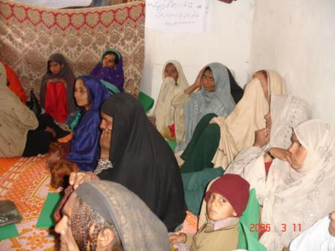
a. Women Empowerment Projects:
Women in Pakistan are amongst the most deprived and marginalized within the country. Located in far-flung villages, on high mountainous terrain often inaccessible from market and other facilities, these women are unaware about their political rights, unable to exercise their right to vote and contest since the inception of Pakistan. In addition, the conservative patriarchal set up does not let these women participate in decision making process at household, community and higher levels.
Community Activist Women Meeting
It is on the honor of ED WAJ to design and implement 3 major women focused projects i.e. British Council funded Gender Equality Project (GEP) in district Battagram in the year 2 005-2006 as Project Manager, RNE funded project on capacity building for elected labor/peasant/minority councilor in KPK, in January 2002 - Sep 2003 as a Provincial Coordinator with PILER and women voter mobilization project in 2012-13, funded by FAFEN as Project Manager.
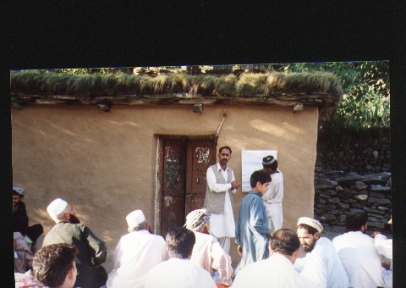
The objective behind these projects was to create ggreater interest among women and general public about the LG system and elections. Capacitating women, labor and peasant councilors about their roles and responsibilities and mobilizing women voters in pocket of district Mansehra where women were bar to cast their votes. Success of these project was that Total 77 women contested the election and 38 women won the election first time in the history of Battagram. As a res ult of women voter mobilization, women casted their votes and turnover increased to 50%.
Community Mobilization
Present LG government system has provided opportunity for women to participate in political process to strengthen collective and democratic public action in support of their demands for practical and strategic needs, throughout Pakistan. But women of most of the district could not avail this opportunity during the 2001 elections and remained deprived of their political rights.
Women were not given right to cost vote and during 2001 and 20015 LG Elections majority of the women in various district of KPK district could not cast their vote.
In Battagram local influential and some religious parties passed a resolution in tribal Jirga and threatened CSO and declared that CSO will be dealt with irony hands and tribal code of conduct that will run women political awareness program or campaign in their district
Projects Implemented As a Partner Free & Fair Election Network (FAFEN)
Democratic Governance Project (DGP)
WAJ ED Implemented FAFEN and EU supported project with Sungi under its in 6-constituencies and 4-district of Hazara Division.
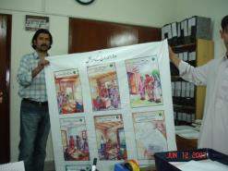
Objective of DGP was to introduce democratic reforms within the country by facilitating ongoing dialogue between citizen and their elected representatives and to encourage people-centered legislation and policy making in order to strengthen the overall process of democracy. Following were the component of DGP project;
- Governance monitoring
- Political & Electoral Violence Education
- Election Observation
- Constituency Relations
- Voter Registration and CNIC formation

- Implemented voter mobilization project in 6-constituencies and 4-district of Hazara Division in 2007

- Implemented voter registration project in same area

EU funded Long Term Election Observation and oversight Project Term Election Observation and Oversight in Pakistan (LTEOOP), January - December 2013, Team Leader Sungi/FAFEN
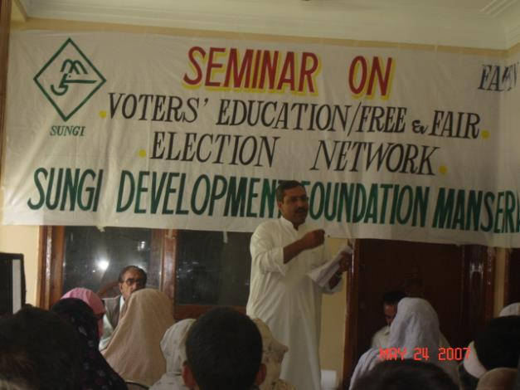
As a team leader of this project, WAJ ED implemented project activities in 5-district of Hazara Division, covering all the 6- National Assembly constituencies. Focus of this project was to strengthen democratic institutions and practices through greater public trust in transparent and accountable electoral processes and enforcement of election laws leads to greater trust of political parties and people. Following key activities were carries out under his project;

- Identification, profiling, training and placement of pre-election election observers in 6-constitecines of Hazara division
- Receiving pre-election reports and submitting to FAFEN
- Identification, profiling, training and accreditation of election observers
- Placement of observers in assigned polling station
- Receiving election-day report and sending to FAFEN
Assit: Election Commissioner Mansehra
- Deputing post-election observers in 6-constocies
- Receiving and sharing post-election litigation report to FAFEN

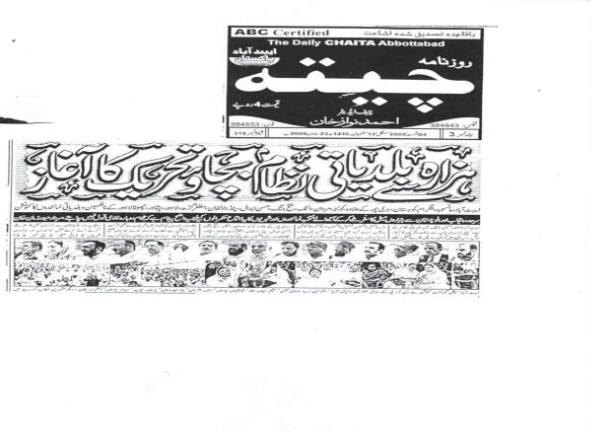
Contribution in Revival of LG system campaign
WAJ facilitated a series of district level consultation seminars on “Threats to LG System” in Hazara division after the system was suspended in Dec 2009. The objective behind the campaign was to compile the opinion of various stakeholders about the formulation of new LG system in KP and sending it to the provincial government for incorporating in final bills. The participants of various seminars including WAJ’s community partners, ex-LG elected representatives, ex- women councilors networks, media persons, government line agencies, religious leaders, academicians, notables, and representatives of various professional unions and other intellectuals. WAJ major demand was to restore a LG system in the province that must be based on following 5-fundamentals given by NRB ;

- Devolution of political power
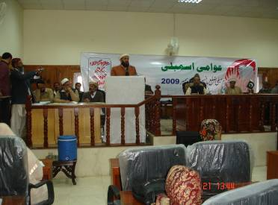
- Decentralization of administrative authority
- De-concentration of management functions
- Diffusion of the power–authority nexus
- Distribution of resources at the district level

Charter of Demands (CoDs) : WAJ was active part of formulating following 22-point CoD;
- Revival of LG system through a consultative process and in line with public pronouncements of major political parties about strengthening the participatory form of democracy at local level
Nazim District Mansehra

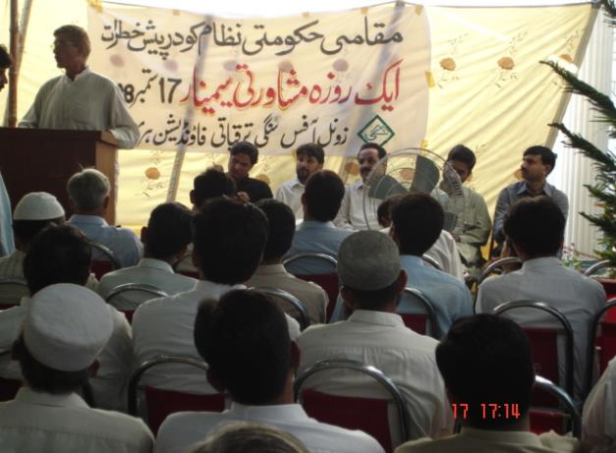
- Unless all stakeholders are consulted – including the public, political parties, civil society, local councilors, and elected representatives at national and provincial levels, representatives of socially, economically and politically marginalized segments of society and media –any reform in the local governance system will lack legitimacy and public trust

- Any attempt to change the true LG system radically in favor of provincial powers would have serious negative implications on the already skewed balance of powers and poor state of development and would significantly undermine public participation in democratic processes

- Under Article 32 of Constitution of Pakistan , an inclusive LG system that empowered marginalized and neglected deprived segments of the society, women, minorities, laborers and the farmers is the need of the day

- A system that eliminates ‘One Man Show’ and pave the way for nourishing democratic attitude and behavior at the grassroots should be formulated

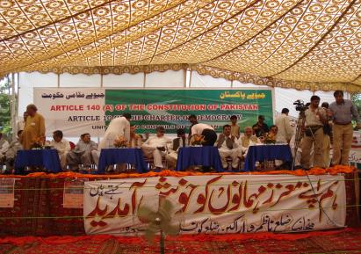
- LG system is the nursery of alternate political leadership so it should be made more vibrant to stop the entry of non-democratic forces in governance though LG as a tool.

- Local Government (LG) system empowered women, laborers and the farmers to assert their fundamental rights and work for the protection and promotion others rights so it should be continued

- Reform the LG system with the aim of enhancing the empowerment of people in line with the democratic spirit

- Abolish all modes of indirect election at the local levels

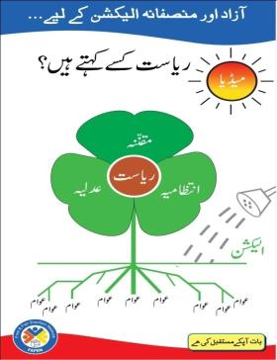
- Hold local elections under election commission of Pakistan and on party basis. Political parties are central to a robust democracy. Unless political parties are strengthened and structured close to people, democracy cannot takes it root

- Do not give executive officers magisterial powers, which would undermine the independence of the judiciary that is insulated from all executive and political influence

- Maintain to 33% or increase representation of women, peasants, workers and minorities in LG institutions and enhance their ability to participate meaningfully in decision-making processes through new LG bill

- Review distribution of powers among the three tiers of the LG in order to inculcate efficiencies, checks and balances.

- Make District and Tehsil Nazims answerable to the district and tehsil assemblies, respectively
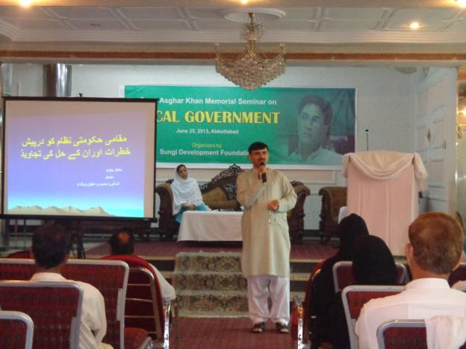
- Union Council should be taken as the basic unit of governance at the grassroots with enhance roles and responsibilities, some of which can be shifted from district and tehsil

- For true and meaningful representation and participation of kissan and labourers, it is necessary that to amend the electoral laws and procedure so to stop the election of irrelevant peoples on these seats.

- Revisiting the authorities and responsibilities between the province and LG

- Need to redefine the fiscal matters between provinces and LG. LG fund can be crated

- Extending the local taxes

- LG should be added in curriculum

- Institution of ombudsman at the district level need to be functional

- Local govt; commission need to be restructured on merit

Capacity Building Challenges to present LG system
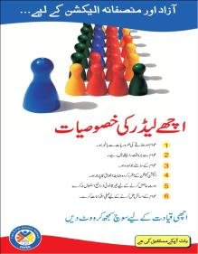
In KP 43,000 people were elected as LG representatives in 25 districts but to develop their capacity to run their business in an effective manner is yet to be done. The issues elected LG representative are facing in KP are given below
- Huge potential of capacity building of 43,000 elected LG representatives In KP 25 district
- The elected LG members lacks proper orientation/clarity on LG Act 2013/LG system
- Lack of clarity about the authority, role and responsibilities at three tiers
- Lack of guidance how to allocate funds and play effective roles at the local level
- Disparaging support by the government officials
- In the above mentioned backdrop there is a good opportunity for civil society organizations like WAJ to join hands with KP government and various donors play an active role to arrange capacity building programme for elected LG representatives in KP to strengthen the new LG system given by present KP government
:
WAJ experience in capacity building of elected representatives
WAJ and its leadership has sufficient experience in designing and implementing capacity building programme for elected LG councilors, political parties and GLAs. Some of key glimpses are narrated as below;
- Executive Director of WAJ was selected as member working group member by KP Government to formulate KP LG Act 2013.
- He is founding member of Free & Fair Election Network (FAFEN)

- He is founding Trustee of Trust for Democratic Education & Accountability (TDEA)

- He has 25 year of experience as governance and advocacy expert, 17 year working experience design and implement various capacities building programme for diverse group of audience including LG representatives, political parties

- He is also master trainer on LG and 18th amendment.

- Strong liaison skills with establishment of productive working relationships with government officials and Government Line Agencies (GLAs), elected representatives in national and provincial assemblies, political parties, civil society organizations and networks, media, think tanks and advocacy groups in Pakistan.

- He had Conducted trainings and capacity development workshops with elected representatives, political parties and civil society on democratic governance, institutional development, accountability and electoral reforms;
- He remained provincial coordinator of RNE funded capacity building programme for women, Peasant and Kissan Councillors in 2001.

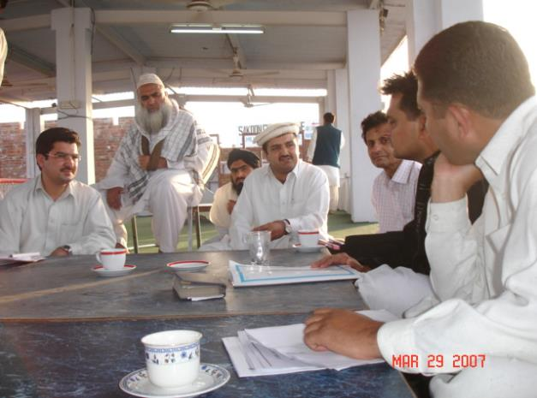
- He designed and implemented British Council Gender Equality Project (GEP) in District Battagram in year 2005.

- Has designed and conducted capacity building for District leadership of political parties in 25 district of KP in 2013.

- Implemented DFID-funded AAWAZ Voice & Accountability Programme, June 2012 – May 2017

- Implemented DFID- and Embassy of Kingdom of the Netherlands funded Project Supporting Transparency, Accountability & Electoral Process in Pakistan (STAEP), 2009-2014,
Meeting with Ziad Akram Durrani Bznnu by-election 2007
- Supervised EU-funded FAFEN’s Long Term Election Observation Project (LTEOOP) Project, January - December 2013

- Supervised DFID funded FAFEN Democratic Governance Project (DGP) 2007-2009

- Supervised NDI funded Political Party’s Capacity Building Project, 2006

WAJ has vast experience organized orientation session and capacity development workshop for LG elected representatives;

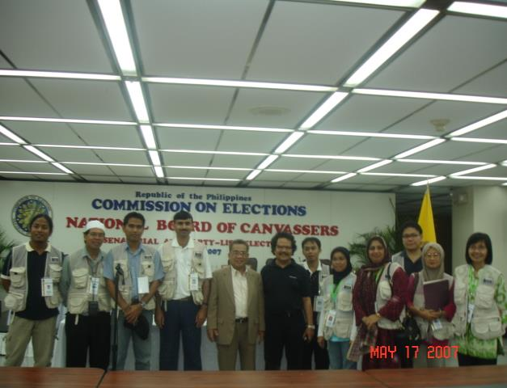
- To orient and educate select local representatives, district/tehsil governments and line departments about the local government system vis-à-vis LG system, their roles and responsibilities, Gender, good governance and budget literacy

- To facilitate local representatives’ increased interaction with local communities and developing a functional system for taking into account their needs and priorities in the preparation of policies and plan at the local government level.

- To provide capacity building support to the local government departments and line agencies and to increase their outreach and coverage at the grassroots level
Philippine international Observers 2007

- To extend guidance and support to select local governments to prepare and implement area/sectorial development plans (VDP and ADP) with active participation of local communities

- He has experience of election observation in country and abroad

